

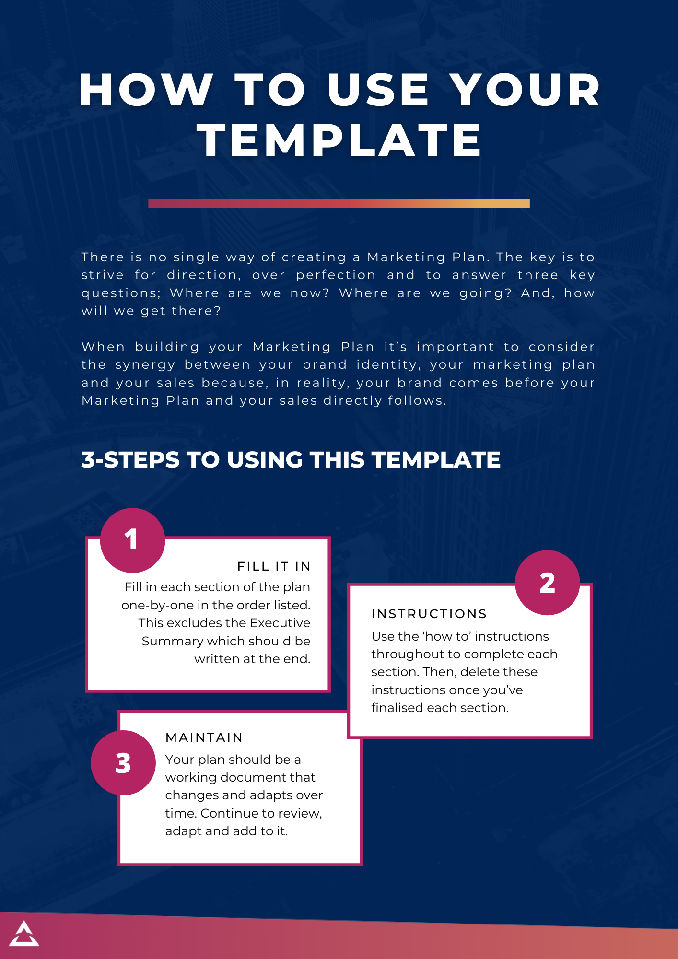

**MARKETING PLAN**

[Your Business Name]

**Contents**

Executive Summary 3

Vision 4

Mission 4

Scope 5

Goals 6

Situational Analysis 7

Market Analysis 8

Competitor Analysis 9

SWOT Analysis 12

Customer Analysis 15

Customer Avatar 15

Customer Buying Process 15

Benefits 16

Product or Service Analysis 16

Strategy 17

Segmentation 18

Targeting 18

Value Proposition 19

Positioning Statement 19

Tactics 19

Product 20

Pricing 21

Place 21

Promotion 22

Implementation 22

Budget 23

Risks and Limitations 23

# 

# **Executive Summary**

| **HOW TO:**  In about 1-page, your Executive Summary should provide an overview of the key information in this plan. It should give readers enough information to understand the direction of the plan without reading the plan in its entirety.  Given your Executive Summary includes all the key information from this plan, it must be the final section written, even though it appears first in the plan.  Key information to summarise in your Executive Summary includes:   * Vision * Mission * Scope * Goals * Strategies * Tactics * Budget |
| --- |

# **Vision**

| **HOW TO:**  Everything in your marketing plan should align to your overall business objectives. Therefore, it is essential to begin your plan by identifying the Vision of your business as this articulates the purpose of your business.  For example, the Vision at The Entourage is *“To move the world forward, through entrepreneurship”.*  If you have not yet crafted your business Vision, you should work with key members of your team to do this. Your Vision makes up the DNA of your business and should be considered in all your business decisions.  Accelerate and Elevate level members at The Entourage can check out the ‘Vision, Mission, Values’ workshop on The Entourage On Demand to learn more about creating a Vision for your business. |
| --- |

[Write your Vision here]

# **Mission**

| **HOW TO:**  Whilst your Vision articulates your ultimate business goal, your Mission is your approach to achieving this goal. It’s what you strive for every day.  Just like your Vision statement, identifying your business Mission at the beginning of your Marketing Plan guides your decisions throughout the plan so they are well-aligned to your overall business objectives.  The Mission at The Entourage is: *“We empower entrepreneurs by giving them everything they need to build great businesses and live meaningful lives”.*  If you’re yet to craft your business Mission, you should work with key members of your team to do this. Like your Vision, your Mission makes up the DNA of your business and should be considered in your business decisions.  Accelerate and Elevate level members at The Entourage can check out the ‘Vision, Mission, Values’ workshop on The Entourage On Demand to learn more about creating a Mission for your business. |
| --- |

[Write your Mission here]

# **Scope**

| **HOW TO:**  After you’ve identified your business Vision and Mission, you need to clarify the scope of this plan. This means you need to identify the product/s or service/s this plan addresses.  Marketing Plans can be made for one particular product or service, a suite of products or services, or all your products or services. This said, it is essential to identify what product/s or service/s your plan is addressing upfront by specifically listing them in your Scope. |
| --- |

[Write your Scope here]

# **Goals**

| **HOW TO:**  Once you’ve clarified the scope of your plan, it’s time to articulate the key goals of the plan.  Looking at your customer journey from a marketing lens, list one goal for each part of their journey. For example, one goal for ‘awareness’, ‘consideration’, ‘purchase’, ‘loyalty’, and ‘advocacy’.  Remember to always refer back to your business Vision and Mission to ensure these goals are aligned to your businesses highest purpose. Understanding these goals will guide the remainder of your plan. |
| --- |

[Write your Goals here]

# **Situational Analysis**

| **ABOUT SITUATIONAL ANALYSIS**  The previous sections of your plan were about identifying your business direction so you can align your plan to your business direction.  In this next section, ‘Situational Analysis’, you are going to look at the current state of the market, competitors, the internal and external environment, and your customers in order to inform your Marketing Strategy and Tactics later in this plan.  This section involves a lot of research. Be sure to source information ethically using factually based, publicly available sources. |
| --- |

## Market Analysis

| **HOW TO:**  Begin your Situational Analysis with an assessment of the current market in which you’re entering, or already reside in, with the product/s or service/s being addressed in this Marketing Plan. In your Market Analysis, the objective is to identify the growth and revenue opportunities in the market.  In this section you need to identify your ‘Total Available Market’, ‘Market Penetration’ and ‘Market Share’. Use the below instructions to calculate these.   1. Calculate your ‘Total Available Market’: This is the total revenue opportunity in the market. Unless you monopolise the market, you will not reach this full revenue potential, but it gives a gauge on the possibilities to work towards.  ***(Your Average Sale Per Customer Per Year) x Total Potential Customers***  Example 1: I sell on average $100 worth of services per customer per year in Sydney and there are 300,000 potential customers in Sydney. $100 x 300,000 = $30,000,000 is the revenue opportunity in this market.   Example 2: I sell on average 400 products at a cost of $10 each to distributors in Sydney and there are 500 distributors.  (400 x $10) x 500 = $2,000,000 is the revenue opportunity in this market.  Example 3: I sell a product for $300,000 payable over three years (therefore $100,000 annually) and there are 1000 potential customers.  $100,000 x 1000 = $100,000,000 is the revenue opportunity in this market.   1. Use the above calculation (in point 1) to determine the ‘Total Available Market’ for the four key segments in the market. This additional step is important as it helps you target your Market Strategy in the sections that follow.    1. Qualified customers that are not buying    2. Your current loyal customers, only purchasing from your business    3. Customers that are buying from both you and your competitors    4. Customers that are currently only buying from your competitors. 2. Calculate your ‘Market Penetration’. This is the percentage of the market utilising product/s or service/s from the total number of potential customers in that market.   ***Total Sales in the industry for 1 yr / total available market*** Using the example in point 1: Between you and your competitors, $6000 worth of lipsticks are being sold to 400 distributors, and the total addressable market is $96 000 000 (as calculated in point 1).  ***($6000 x 400) / 96 000 000 = 0.025***  The lower this number, the greater the opportunity for growth. 3. Calculate your ‘Market Share’. This is the total number of sales in the industry contributed by one individual business.   ***Your business sales for 1 yr / Total market sales for 1 yr***   The lower this number, the greater the opportunity for growth. |
| --- |

[Write your Market Analysis here]

## Competitor Analysis

| **HOW TO:**  The second part of the Situational Analysis is conducting a Competitor Analysis. This allows you to understand what your competitors are doing, benchmark your business, identify opportunities for a competitive advantage, leverage what they do well, and identify market trends.   1. Identify your top 5 competitors. These may be direct competitors (i.e. exact same offering as you e.g. two Italian restaurants competing with each other), or indirect competitors (i.e. fulfills the same customer needs with a different offer e.g. an Italian restaurant and a Japanese restaurant competing with each other). 2. Fill in the below templatefor each competitor. Simply copy and paste the template for each competitor analysis. 3. Analyse the information you have populated in your templates and write it into this section of the plan to inform your Marketing Strategy and Tactics later in this Marketing Plan.    1. How do you benchmark yourself against competitors?    2. What are they doing well that you can amplify that in your business?    3. What are their weak areas that you can use to your advantage?    4. Are there any trends in marketing within your industry?    5. What kinds of offers and marketing does your audience respond to?    6. What marketing strategies are working for your competitor/s and how can you leverage these to inspire your own? |
| --- |

| **Competitors Name** | | |
| --- | --- | --- |
| **Background** | | |
|  | Location: Where do they operate? | |
|  | Products/Services: What do they sell? | |
|  | Pricing: What is their pricing structure? | |
|  | UVP: What is their Unique Selling Proposition (UVP)? | |
| **Annual Report Data (If available)** | | |
|  | Market Share: What is their market share? Has it increased, decreased or stayed the same? | |
|  | Revenue: What is their revenue? Has it increased, decreased or stayed the same? | |
|  | Sales volume: What is their volume of sales? | |
| **Marketing Strategy and Tactics Overview** | | |
| What is their strategy and their tactics? See sections on ‘Strategy’ and ‘Tactics’ later in this plan if you require more information on what these are. | | |
| **Strengths** | | **Weaknesses** |
| * List their strengths. Things to consider include; whether customers like/dislike them, budget, resources, customer reviews/ratings. | | * List their weaknesses. Things to consider include; whether customers like/dislike them, budget, resources, customer reviews/ratings. |

[Insert competitor analysis templates here, followed by a summary of answers to the analysis questions listed in point 3 of the ‘how to’ section.]

## SWOT Analysis

| **HOW TO:**  Next, conduct a SWOT Analysis (Strength, Weaknesses, Opportunities and Threats Analysis) to become informed about the dynamics of the world outside of your business, as well as the factors within your business, that may impact on your business performance.  A SWOT Analysis allows you to take an informed, strategic and proactive approach when making business decisions, including when setting your Marketing Strategy and Tactics later in the Marketing Plan.  All the factors you include in your SWOT Analysis should be based on facts, NOT assumptions.   1. Identity the Strengths of your business that your competitors don’t have. For example, resources, unique talent, skills, abilities, intellectual property, motivation, processes, materials, partners, suppliers, value proposition, systems, procedures, and how customers and competitors view you. 2. Identity the Weaknesses of your business that your competitors may take advantage of. For example, resources, unique talent, skills, abilities, intellectual property, motivation, processes, materials, partners, suppliers, value proposition, systems, procedures, and how customers and competitors view you. 3. Identity the Opportunities for your business in an external environment that you can take advantage of. For example, policy, trends, lifestyle, competition, market developments, technology, societal patterns, supply chain. 4. Identify the Threats to your business in the external environment that you need to be aware of. For example, policy, trends, lifestyle, competition, market developments, technology, societal patterns, supply chain. 5. Prioritise your results to include only your top 5 considerations in each area 6. Analyse your SWOT Analysis table using the below questions and record key insights that might help your Marketing Strategy and Tactics later in this Marketing Plan.    1. How can you leverage and enhance your strengths?    2. How can you mitigate or reduce the impacts of your weaknesses?    3. How can you take advantage of the opportunities?    4. How can you manage the impact of threats?    5. Would more opportunities present themselves if you bolstered your weaknesses?    6. Can your strengths be used to reduce threats?    7. Can your strengths enhance your ability to leverage opportunity?    8. Can your weakness be strengthened with the opportunities?    9. Can your weaknesses be worsened with the threats?    10. Can strengthening weakness allow you to tap into more opportunity? |
| --- |

[Fill in the below table using points 1-4 as a guide.]

| **Internal Factors** | |
| --- | --- |
| **Strengths** | **Weaknesses** |
|  |  |
| **External Factors** | |
| **Opportunities** | **Threats** |
|  |  |

[Insert your answers to the SWOT Analysis questions (point 6) here.]

## Customer Analysis

| **HOW TO:**  Next, conduct an analysis of your customer. The idea is to learn the intricacies of your customer so you feel like you know them. The information gained in this process will be foundational to the decisions you make in your Marketing Strategy and Tactics section of this Marketing Plan. |
| --- |

### Customer Avatar

| **HOW TO:**  Bring your customer to life by creating an avatar of them. To do this, identify;   * Demographics e.g. age, gender, marital status, family, location, job, income, education * Wants and dreams e.g. what do they want to achieve? What motivates them? * Fears and frustrations e.g. what keeps them up at night? What do they want to avoid or alleviate? * Interests, lifestyle and hobbies e.g. what do they read, watch on TV, listen to on radio/podcasts, events they attend, follow online and do for fun * Objections e.g. why might they not want to purchase from you? * Role e.g. what is their role in the decision-making process? * Influences e.g. who influences their decisions?   If you are an Accelerate or Elevate member with access to our ‘Customer Avatar Builder Template’, you can use that template to build your Avatar, then you can simply download it as an image and insert the image directly into your plan. |
| --- |

[Write or insert your Customer Avatar here]

### Customer Buying Process

| **HOW TO:**  Identify your customers buying process and the actions they would take at each stage in the buying process, including awareness, search for alternatives, evaluation, purchase and post purchase. |
| --- |

[Write your Customer Buying Process here]

### Benefits

| **HOW TO:**  List the benefits your customers are hoping to get from a product or service in your category. This is important to ensure alignment between the benefits of your product/service (discussed in the next section ‘Product or Service Analysis’) and the benefits your customers are seeking. |
| --- |

[Write your Benefits here]

## Product or Service Analysis

| **HOW TO:**  It is essential that you align your product or service with the right target audience. The advantage of completing the previous ‘Customer Analysis’ section means you are now aware of the benefits your customers are seeking. In this section, you will identify the key features of your product/service and match these features with the benefits your customers are seeking.   1. List up to 5 main features of your product or service, and your competitors 2. Match these features with the benefits your customers are seeking 3. Analyse the results:    1. Are there benefits your customers want that you aren’t servicing?    2. Are your features performing better or worse than competitors? 4. Select your feature to carry through into your strategy:    1. Which feature is of high importance to customers and your business is performing best? This should be the focus in your strategy    2. If there isn’t a feature that meets the criteria of point a, select your best feature and aim to re-calibrate the importance of this feature to customers in your marketing. |
| --- |

[Write your Product/Service Analysis here]

# 

# **Strategy**

| **ABOUT STRATEGY**  By now, you will have identified your Vision, Mission, Scope and Goals to define your plan and ensure its alignment to your overarching business objectives. You’ve also completed in-depth research of the current situation which impacts on your product or service’s marketability including market, competitor, SWOT, customer and product/service analysis.  It’s now time to use all the work you’ve completed to set an informed Strategy. Your Strategy overviews how you will segment your customers, the value proposition you offer and your product or service positioning.  Your Strategy forms the overarching direction of the ‘Tactics’ in the section that follows. |
| --- |

## 

## Segmentation

| **HOW TO:**  How will you segment your potential audience to ensure your marketing efforts are laser-sharp in focus? You can divide your audience into segments based on the particular benefits they seek. You can identify this from the Product/Service Analysis completed earlier in this plan and use the feature you identified as your top feature and of most importance to customers, or (if not available), your top feature that you will increase the importance of in the minds of customers. |
| --- |

[Write your Segmentation here]

## Targeting

| **HOW TO:**  Once you’ve segmented your audience, identify which segment you will target first. In this section, you might sharpen the focus of your marketing efforts even more by targeting specific demographics like a particular age, profession or location. |
| --- |

[Write your Targeting here]

## 

## Value Proposition

## 

| **HOW TO:**  Reflecting on the Product/Service Analysis completed earlier in this plan and the benefit/s of your product/service you identified in that section, identify ‘why’ a consumer would use your product/service over those of another business. Your value proposition should be unique from other businesses - something you offer that they don’t. |
| --- |

[Write your Value Proposition here]

## Positioning Statement

| **HOW TO:**  Next, craft a positioning statement that addresses who your target audience is, what your value proposition is (identified in the previous section of the plan), and how you are different.  ***We help [identify your target audience] achieve [key benefit of your product/service, problem you solve, improvements you make] by [how do you do this, what feature of your product/service help them achieve this].*** |
| --- |

[Write your Positioning Statement here]

# **Tactics**

| **ABOUT TACTICS**  Let’s recap your plan so far;   * You’ve identified your Vision, Mission, Scope and Goals to define your plan and ensure its alignment to your overarching business objectives * You’ve completed in-depth research of the current situation which impacts on your product or service’s marketability * You’ve overviewed your Strategy in terms of which customers you will prioritise first, the value you offer them and how you want to be perceived.   Now, you need to identify your ‘Tactics’. These are the finite details around your product/service offering, your pricing, where you will distribute your product/service and how you will promote it.  You can see that each phase of your plan so far has been unpacking layers of consideration to get you to a point where your tactics are aligned to your business objectives, competitive in the market place and well-focused towards your customer and the benefits they seek. |
| --- |

## Product

| **HOW TO:**  In this section, you want to describe your product/service, including:   * Features and benefits * Design e.g. packaging and ergonomics * Complimentary/support products e.g. insulation, accessories, warranty * Consumed e.g. Is it a one-off purchase, subscription and/or does it include support products?   Then, looking at your positioning statement and target audience, determine how well your product/service aligns and suggest improvements to include in your product tactics. |
| --- |

[Write your product tactics here]

## Pricing

| **HOW TO:**  In this section, you want to describe the price of your product/service:   * What is the cost? * Does the price align with your positioning? Why/why not? * Will the target customer purchase at this price? * When will you run pricing discounts and campaigns? * Describe any additional product/service costs * Are there payment or financing options? * Communicating your pricing:   + How are you communicating your pricing so customers are clear?   + How are you communicating value for money?   + When in the customer journey will you communicate pricing? |
| --- |

[Write your pricing tactics here]

## Place

| **HOW TO:**  In this section, you want to describe the channels you will distribute your product/service, based on where your customers are likely to access the product, and with consideration of the benefits and risks of distributing through each channel. You want to describe:   * Where you will distribute * Who is involved in the distribution e.g. list each touchpoint such as warehouse, delivery service, retail outlet, then customer * Quantity of distributors of each type of distributor * How much control over the distribution you will have and what steps you will take at each step in the distribution process to ensure quality control. E.g. manufacturing processes, training for third party retailers, agreements with delivery services etc. |
| --- |

[Write your distribution tactics here]

## 

## Promotion

| **HOW TO:**  In this section, identify your tactical approach for your organic and paid marketing:   * Reiterate who you are promoting to (target audience identified in the previous section) * List the platforms you will use to reach your audience based on where they are likely to be ‘hanging out’ * Identify your message around each channel i.e. how will you specifically use each platform listed to give customers value and engage them best. For example, if you have a restaurant, Instagram stories might be used for micro video content behind the scenes in the kitchen, capturing the food and the ambience of the restaurant * Identify the timing and frequency of each activity * Identify promotional campaigns for the year. |
| --- |

[Write your promotion tactics here]

# **Implementation**

| **HOW TO:**  Now you’ve identified what your Marketing Plan is, it’s time to create an implementation plan around it.   * List the roles, responsibilities and capabilities needed to fulfil the plan * Identify if there are any role, responsibility and capability gaps that need to be filled * Identify which teams and roles are in charge of delivering specific types of content, channels, KPIs etc. (be sure to write the names of the teams and role titles, not the names of a specific individuals). Describe each of them and list what’s needed to successfully execute on the plan * Communicate the plan with key individuals * Use your plan as a working file - listen, learn and iterate your plan throughout the year. |
| --- |

[Write your Implementation plan here]

# **Budget**

| **HOW TO:**  Identify your budget to fulfill this plan. Defining a budget falls into the overall financial planning of your business. You may either write your plan so that it feeds into your overall budget or set your financial plan and make sure your Marketing Plan fulfils your revenue goals.  Accelerate and Elevate level members have access to a Marketing Budget template to complete this section of the Marketing Plan. |
| --- |

[Write your Budget here]

# **Risks and Limitations**

| **HOW TO:**  Your Marketing Plan will never be perfect, which is why it’s important to finish your plan by identifying any key risks and limitations of the plan. This could include:   * Anything that has been left out of the plan * Any areas where more information is needed * Any questions that weren’t able to be answered in the plan, or areas where more information is needed. |
| --- |

[Write your Risks and Limitations here]

